Assessment type: Test 1 calculator allowed Name: _____________________

To be completed in class under test conditions

Task weighting: 12% of the school mark for the Semester Mark ____________/32
______________________________________________________________________________
1 Find the perimeter of the following shape.
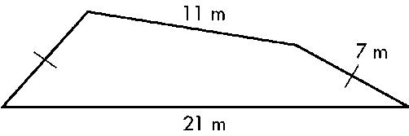

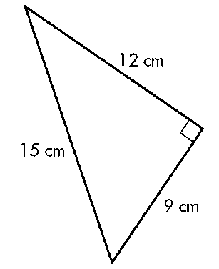
2 Find the area of the following figure.

3 Find the volume of the following solid.
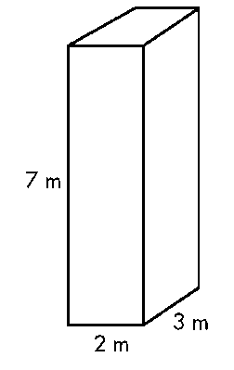

4 Find the volume of the following solid.
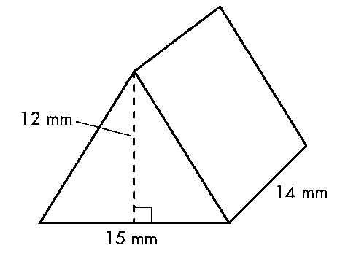

5 The maximum heart can be calculated by the following formula.

Maximum Heart Rate (MRT) = 208 – 0.7 x your age

- What would be the maximum heart rate for a 20 year old?

- What happens to the people’s maximum heart rate as they get older?

- How much does a person’s MHR change over every 10 year period?

6 If one kilogram of apples costs $4.79, calculate the following?

- How much would 1.8 kilograms cost?

- What would 780 grams cost?

- How many kilograms of apples can you buy for $20.00?

7
Darren’s house has lawn at the front. The area of the lawn is 150 m². Darren wants to fertilise the lawn and needs to calculate how much fertiliser is needed. He finds out that the recommended rate of application is 30–50 g per square metre. He decides to use 40 g per square metre.
How much fertiliser will he need? Give the answer in kilograms.

8
Sean and Fiona are a couple with two small children. They have fenced the back of their suburban property so that their children can play there safely. A plan of the area is shown below:
Sand pit
Vegetable garden
Lawn
House
Scale: 1cm represents 1m
D
C
A
B

• the area is the rectangle that is marked ABCD

• the area has a vegetable garden and a sandpit

• the rest of the area is lawn.

• the plan is drawn to scale—1 centimetre represents 1 metre.

- On the plan, write the real-life dimensions of:
  - the sand pit
  - the vegetable garden
  - the rectangle ABCD

- Calculate the real-life area of:
  - the sand pit

  - the vegetable garden

  - the lawn

Solutions
______________________________________________________________________________
1 Find the perimeter of the following shape.


46m


2 Find the area of the following figure.

A = 0.5 x 9 x 12
= 54 cm²

3 Find the volume of the following solid.


V = 2 x 3 x 7
= 42 m³

4 Find the volume of the following solid.


V = (0.5 x 15 x 12) x 14
= 1260 mm³

5 The maximum heart can be calculated by the following formula.

Maximum Heart Rate (MRT) = 208 – 0.7 x your age

- What would be the maximum heart rate for a 20 year old?

MHR = 208 – 0.7 x 20 = 194 beats

- What happens to the people’s maximum heart rate as they get older?

It gets less

- How much does a person’s MHR change over every 10 year period?

0.7 x 10 = 7 beats

- If one kilogram of apples costs $4.79, calculate the following?

- How much would 1.8 kilograms cost?

  - 1.8 = 8.622 kg

- What would 780 grams cost?

  - 4.79 = $3.74 (1mk if not rounded to nearest cent)

- How many kilograms of apples can you buy for $20.00?

20 ÷ 4.79 = 4.175 kg

7
Darren’s house has lawn at the front. The area of the lawn is 150 m². Darren wants to fertilise the lawn and needs to calculate how much fertiliser is needed. He finds out that the recommended rate of application is 30–50 g per square metre. He decides to use 40 g per square metre.
How much fertiliser will he need? Give the answer in kilograms.

150 x 40 g = 6000 g = 6 kg

8
Sean and Fiona are a couple with two small children. They have fenced the back of their suburban property so that their children can play there safely. A plan of the area is shown below:
Sand pit
Vegetable garden
Lawn
House
Scale: 1cm represents 1m
D
C
A
B

• the area is the rectangle that is marked ABCD

• the area has a vegetable garden and a sandpit

• the rest of the area is lawn.

• the plan is drawn to scale—1 centimetre represents 1 metre.

- On the plan, write the real-life dimensions of:
- the sand pit
2 m x 2 m ( value, units)
- the vegetable garden
3 m x 2 m
- the rectangle ABCD
14 m x 12 m

- Calculate the real-life area of:
- the sand pit

4m² ( value, units)

- the vegetable garden
6m²

- the lawn
(168 - 4–6) = 158 m²

